

From: JM Date: 2014-01-17

To: KSL450

The NoTableGen setting (from KSL450 version 813)

By setting the NoTableGen flag in the Settings picture the files:

tablXXXX.vol, tcfXXXX.dat and lcfXXXX.dat

will NOT be generated, overwritten or created when a Save is activated
(from the Menu or from a remote command)

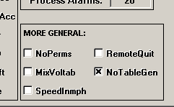

kslinit.* :

"NoTableGen","1"

Registry:

Windows Registry Editor Version 5.00

[HKEY_CURRENT_USER\Software\VB and VBA Program Settings\KSL 450 General\Settings]

"NoTableGen"="1"

